**SmartTech Solution Pvt. Ltd.**

Thapagaun, New Baneshwor

Kathmandu, Nepal

+977 - 01 - 5245027

**User Manual**

**For**

**Asset Management**

**Mobile Application**

# 

**1. Mobile Application** **2**

1.1 Login 2

1.2 Mobile App Module 3

1.2.1 Cashbook 3

1.2.1.1 Add Income 3

1.2.1.2 Add Expenditure 3

1.2.1.3 Other functions in CashBook 4

1.2.2 Maintenance 4

1.2.2.1 Preventive 4

1.2.2.2 Inspection 5

1.2.2.3 Reactive 6

1.2.1.3 Other functions in Maintenance 6

1.2.3 Service 7

1.2.3.1 Supply 7

1.2.3.2 Quality Tests 8

1.2 Notification 8

# 

# 1. Mobile Application

## 1.1 Login

1. In order to login, the user has to fill in the following details:
   1. 10 Digit authorized mobile number
   2. Pin number which should be at least 4 digits

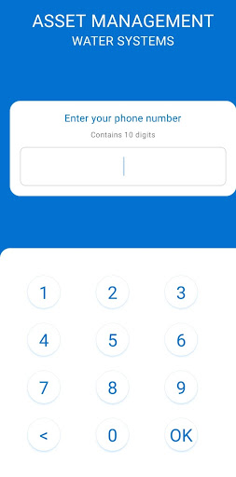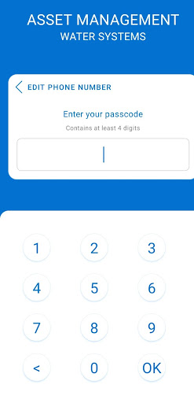



1. After logging in into the mobile app, the user will be able to view different mobile app modules like Cashbook, Maintenance, and Services with different dates in the year of the Water System. In this app, there is an availability of selecting two languages: English and Nepali. In order to change the language:
   1. User has to click on top of the app where there is an icon of the flag (EN &US) as per the user preference language.

## 1.2 Mobile App Module

There are mainly 3 tabs in the mobile application. They are Cashbook, Maintenance, and Service.

### 1.2.1 Cashbook

In the cashbook tab, there are two main sections. They are Income & Expenditure. In the income section, selection of different income categories along with the Income title input fields with their respective amount as per the given year of the water system, as well as date selection is available. When the user taps on the Plus(+) button, a pop-up like a box will appear in order to add income and expenditure.

#### 1.2.1.1 Add Income

While adding the income, the following details are required:

1. Select category: The user has to select a category from the list of multiple income categories
2. Select date: The user has to click on the calendar icon and needs to select the date
3. Income Title: User has to add the income title compulsory
4. Income Amount: User has to add the income amount as per the income title
5. User has to add the water supplied (in liters) or also you can keep it 0 if there is no specific water supply
6. Save the added data by clicking on the SAVE Button.

#### 1.2.1.2 Add Expenditure

While adding the income, the following details are required:

1. Select category: The user has to select a category from the list of multiple expenditure categories
2. Select date: the user has to click on the calendar icon and need to select the date
3. Income Title: User has to add the expense title compulsory
4. Expense Amount: The user has to add the expense amount as per the expense title
5. Remarks: User has to add the remarks

#### 1.2.1.3 Other functions in CashBook

1. On the right side of the app, there is a filter button: month and week, where the user can view the income and expenses by using the filter.
2. There is a Close button at the end of the Cashbook tab where users can confirm closing for the month.
3. Users can also select and submit the image of the cashbook for the given month.
4. And the accounts closed cannot be reverted.

### 

### 1.2.2 Maintenance

In the maintenance tab, there are mainly three sections. They are Preventive, Inspection and Reactive. In every section, there are maintenance records as per the maintenance components and categories as per the given year of the water system. Users can add the maintenance log by filling up the following required data.

#### 1.2.2.1 Preventive

In the preventive section, there are multiple lists of components as per the maintenance interval year. The user has to add the maintenance log by clicking on one of the maintenance lists.

1. Click on the ADD button from one of the lists
2. After clicking on the ADD button, a pop-up that contains a form appears where data regarding preventive maintenance log has to be added. Following data are required to fill in the log:
   1. Select the date: the user has to click on the calendar icon and needs to select the date
   2. Interval (in days): The user has to add the interval as per the required maintenance days 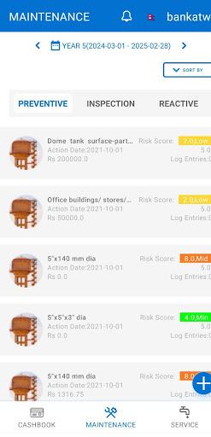
   3. Total cost: The user has to add the total cost of the maintenance without any cost separation
3. There is a box: Add cost separately where the user has to click on that box and three different fields will appear. They are:
   1. Labour: User has to add the Labour cost
   2. Material: User has to add the material cost
   3. Replacement: User has to add the Replacement Cost
   4. Select the picture: User has to select the picture of the maintenance component
   5. Remarks: User has to add the remarks
   6. Save the added data by clicking on the SAVE LOG.

#### 1.2.2.2 Inspection

In the Inspection section, there are multiple lists of components as per the maintenance interval year. The user has to add the inspection log by clicking on one of the maintenance lists.

1. Click on the ADD button from one of the lists
2. After clicking on the ADD button, a pop-up like a form appears where the inspection maintenance log has to be added. Following data are required to fill in the log:
3. Select the date: the user has to click on the calendar icon and needs to select the date
4. Interval (in days): The user has to add the interval as per the required maintenance days
5. Total cost: User has to add the total cost of the maintenance without any cost separation
6. There is a box: Add cost separately where the user has to click on that box and three different fields will appear. They are:
7. Labour: User has to add the Labour cost
8. Material: User has to add the material cost
9. Replacement: User has to add the Replacement Cost
10. Select the picture: User has to select the picture of the maintenance component
11. Remarks: User has to add the remarks
12. Save the added data by clicking on the SAVE LOG.

#### 1.2.2.3 Reactive

In the Reactive section, there are multiple lists of components as per the maintenance Interval Year. The user has to add the maintenance log by clicking on one of the maintenance lists.

1. Click on the ADD button from one of the lists
2. After clicking on the ADD button, a pop-up like a form appears where the reactive maintenance log has to be added. Following data are required to fill in the log:
3. Select the date: The user has to click on the calendar icon and needs to select the date
4. Interval (in days): The user has to add the interval as per the required maintenance days
5. Total cost: The user has to add the total cost of the maintenance without any cost separation
6. There is a box: Add cost separately where the user has to click on that box and three different fields will appear. They are:
7. Labour: User has to add the Labour cost only
8. Material: User has to add the material cost only
9. Replacement: User has to add the Replacement Cost only
10. Select the picture: User has to select the picture of the maintenance component
11. Remarks: User has to add the remarks
12. Save the added data by clicking on the SAVE LOG.

#### 1.2.1.3 Other functions in Maintenance

1. On the maintenance tab, there is a Plus(+) Button where the user has to add Not Scheduled Maintenance. After clicking on the Plus(+) Button, a pop-up form appears where the non-scheduled maintenance log has to be added.
   1. Maintenance Log: The user has to select one of the maintenance components from the given component lists.
   2. Select date: the user has to click on the calendar icon and needs to select the date
   3. Possible failure: User has to add the possible failure of the maintenance component
   4. Maintenance action: User has to add the maintenance action of the maintenance component
   5. Interval (in days): User has to add the interval as per the required maintenance days
   6. Total cost: The user has to add the total cost of the maintenance without any cost separation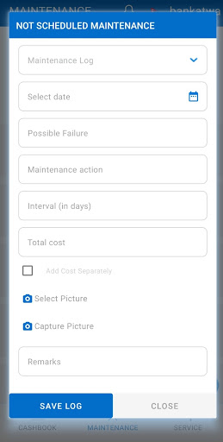
2. There is a box: Add cost separately where the user has to click on that box and then three different fields will appear. They are:
   1. Labour: User has to add the Labour cost only
   2. Material: User has to add the material cost only
   3. Replacement: User has to add the Replacement Cost only
   4. Select the picture: User has to select the picture of the maintenance component
   5. Remarks: User has to add the remarks
   6. Save the added data by clicking on the SAVE LOG.
3. On the Right Side of the app, there is a SORT BY button: Action Date, Est. Cost & Risk Score where the user can view the maintenance list by clicking on the SORT BY Button.

### 1.2.3 Service

In the Service tab, there are mainly two sections. They are Supply & Quality Tests. Users can add supply of water and quality tests as per the Water System.

#### 1.2.3.1 Supply

In the supply section, the user has to add the water supply record. In order to add the water supply records, the following data are required:

1. Start Date: The user has to click on the calendar icon and needs to select the Start date.
2. There is a box: Add record for a date range where the user can add the water supply record within the interval of the date. User has to click on that box and then another Field for the End date will appear on the same form.
   1. End date: the user has to click on the calendar icon and needs to select the End date.
   2. Total Daily Supply: User has to add the total daily supply of the water
   3. Estimated Households: Users have to add the estimated households of the water system they are using.
   4. Estimated Beneficiaries: Users have to add the estimated beneficiaries of the water system.
   5. Save the added data by clicking on the SAVE RECORDS.

#### 1.2.3.2 Quality Tests

1. In the Quality Tests section, the user will be able to add the water test results. In order to add the water test results, the following data are required:
   1. Start Date: the user has to click on the calendar icon and needs to select the Start date.
2. There is a box: Add a record for a date range where the user can add the water test results within the interval of the date. The user has to click on that box and then another Field for the End date will appear on the same form.
   1. End date: the user has to click on the calendar icon and needs to select the End date.
   2. User has to add the water quality test's value of given Turbidity, Aluminium, Zinc, Copper, Sulphate, etc
   3. Save the added data by clicking on the SAVE RECORDS.

## 1.2 Notification

At the top of the mobile app, there is a Notification icon where the user will be able to view notifications regarding income, expenditure, and service with the specific date.

**Thank you**